**Scenario:**

Consider a **Garment system** where foreign buyer gives some order to the garment. The garment management receives the order and distributes the work to its employees. After the completion of work Tester (QC) checks the work and finally shipment (delivery) has been done by the management. (All the users need to **register** into the system).

Now prepare Logical design for the system and then develop the software for this system (according to the logical design).

**Row Requirement:**

1. We have to make a Garment Management System.
2. All user must register into this system.
3. Foreign Buyer gives order.
4. Garment management can receive this order.
5. Management distributes the work to its employee.
6. Work Tester (QC) checks the work according to order.
7. Satisfied product are delivered by the management.

**Software Requirement Specification:**

|  |  |  |  |  |
| --- | --- | --- | --- | --- |
| **SRS id** | **SRS Name** | **Description** | **SRS Type** | **Priority** |
| SRS-01 | Garment System | We have to make a Garment System. | FR | HIGH |
| SRS-02 | User Registration | All user must register into this system to use. | FR | HIGH |
| SRS-03 | Order giving | Foreign Buyer gives order. | FR | HIGH |
| SRS-04 | Order receiving | Garment management receives this order. | FR | HIGH |
| SRS-05 | Work distribution | Management distributes the work to its employee. | FR | MODERITE |
| SRS-06 | Product checking | Work Tester (QC) checks the work according to order. | NFR | HIGH |
| SRS-07 | Product delivery | Satisfied product are delivered by the management | FR | HIGH |

Where, NFR=Non-functional Requirement, FR=Functional Requirement.

**Use Case Diagram:**

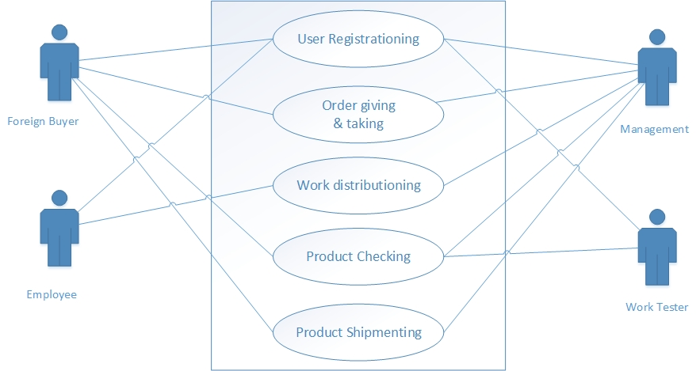

**Context Diagram:**

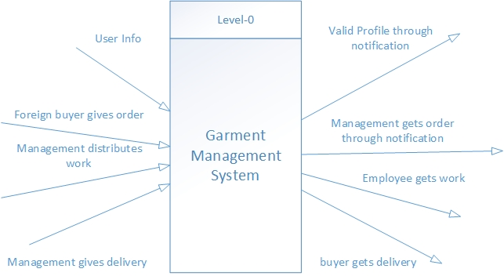

**Level-1 DFD:**

